Project Development Phase

# Sprint - I

|  |  |
| --- | --- |
| Date | 14 NOVEMBER 2022 |
| Team ID | PNT2022TMID40586 |
| Project Name | Industry-Specific Intelligent Fire Management System |

**Link:** https://wokwi.com/projects/322410731508073042

# OUTPUT:

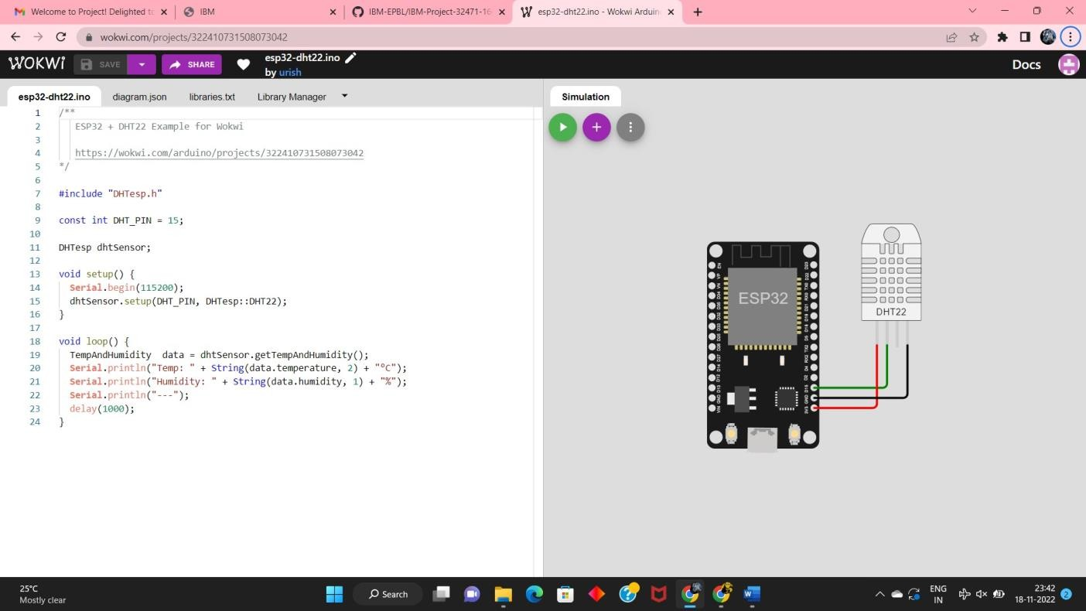

**CODE:**

#include <time.h>

bool exhaust_fan_on = false; bool sprinkler_on = false;

float temperature = 0; int gas = 0;

int flame = 0;

String flame_status = ""; String accident_status = ""; String sprinkler_status = "";

void setup() { Serial.begin(99900);

}

void loop() {

//setting a random seed srand(time(0)); //initial variable

temperature = random(- 20,125); gas =

random(0,1000); int flamereading =

random(200,1024); flame =

map(flamereading,0,1024,0, 2);

//set a flame status

switch (flame) { case 0:

flame_status = "No Fire";

Serial.println("Flame Status : "+flame_status);

break; case 1:

flame_status = "Fire is

Detected";

Serial.println("Flame Status : "+flame_status);

break;

}

//Gas Detection if(gas > 100){

Serial.println("Gas

Status : Gas leakage Detected");

}

else{ exhaust_fan_on = false; Serial.println("Gas

Status : No Gas leakage Detected");

}

//send the sprinkler status if(flame){ sprinkler_status =

"working";

Serial.println("Sprinkler Status : "+sprinkler_status);

}

else{ sprinkler_status = "not

working";

Serial.println("Sprinkler Status : "+sprinkler_status);

}

//toggle the fan according to gas

|  |  |  |  |  |
| --- | --- | --- | --- | --- |
|  | | | | |
| if(gas > 100){ exhaust_fan_on  = true;  Serial.println("Exhaust fan Status : Working");  }  else{ exhaust_fan_on = false;  Serial.println("Exhaust fan Status : Not Working");  }  Serial.println("");  Serial.println("");  Serial.println(" --  /*************/-------  ");  Serial.println("");  Serial.println("");  delay(2000);  }  **TEST CASES:** | | | | |
|  | **S.NO** | **INPUT** | **OUTPUT** | **RESULT** |
| 1 | Gas:62 Temperature:45.30 Flame:366 | Exhaust Fan: Not Working  Sprinkler: Not Working Status Logged: Done | PASSED |
| 2 | Gas:598  Temperature:51.40 Flame:412 | Exhaust Fan: Working Sprinkler: Not Working Status Logged: Done | PASSED |

|  |  |  |  |  |
| --- | --- | --- | --- | --- |
|  | | | | |
|  | | | | |
|  | 3 | Gas:334  Temperature:49.30 | Exhaust Fan: Working Sprinkler: Working | PASSED |
|  | Flame:912 | Status Logged: Done |  |
| 4 | Gas:18 Temperature:67.90 | Exhaust Fan: Not Working | PASSED |
|  | Flame:745 | Sprinkler: Working |  |
|  |  | Status Logged: Done |  |
| 5 | Gas: 354  Temperature:69.30 | Exhaust Fan: Working Sprinkler: Not Working | PASSED |
|  | Flame:446 | Status Logged: Done |  |